Banking record SYSTEM

TA:نوري حمدي علي حسن

The Project Team:

|  |  |  |
| --- | --- | --- |
| Name | ID | Role |
| يوسف عادل سليمان سليمان | 20201701018 | Team Leader, User Level functions and Project Reformation. |
| مينا اشرف ميحائيل صالح | 20201700888 | Co-leader  Prototype Design, User level function and Project Documentation |
| حازم عبدالكريم سعد محمد | 2201701261 | Admin Panel Functions |
| يوسف عمرو محمد سامي | 20201701027 | Admin Panel Functions |
| عبدالله محمد علي محمد | 20201700467 | Admin Panel Functions |
| اكرامي احمد محمد عبيد | 20201700127 | Bug bounty hunter and Transfer Function |

**Project Summary:**

This project is a banking record system, upon running the program you are directed to the login page which asks for username and password input, if the predetermined admin credentials (Username = “Admin” and Password = “Admin”) are entered, the admin is redirected to the admin panel where they have access to all data in the application. The administrator has multiple admin restricted functions including Create account, Modify account, Close account and List accounts. If, however, the data that is entered at the login page correspond to an existing user in the program database, they are directed to the user panel in which they have access to user level functions which are Balance inquiry, Deposit, Withdraw and Transfer.

The program has the essential login functions which check whether the user entered the right password or not and a logout function to allow switching between different users if needed.

The app is built to support reading and writing data from and to files, which makes for flexible user experience, this is done through the Import and Export functions which transfer the data back and forth between arrays and text files for convenience.

(There are pictures provided documenting different scenarios of the program below)

**Functions Brief Documentation**

void import()

-Function that imports data from text files to arrays to allow for easy data manipulation.

void login()

-Function that takes username and password input from the user and directs the user to the proper panel.

void user_pannel()

-If the login data correspond to a user, this function is called, this function allows the user to navigate between the various user functions which are enquiry, withdraw, deposit and transfer.

void admin_pannel()

-If the login data correspond to an admin user, this function is called, It allows the admin to navigate between multiple admin functions like create, modify, delete and list.

bool user_login(string, string)

-Function that takes the username and password input as an argument and then it compares it to the ones saved in the database to check if it is a correct login or not.

bool userexists(string)

-Function that takes the username as argument to check whether it already exists or not in the database, the function returns true if the user exists and false otherwise.

void createaccount()

-Function that allows the admin to add a new account to the system.

void listusers()

-Function that allows the administrator to list all users registered on the system.

void deleteaccount()

-Function that allows the administrator to delete a specific account.

void modify()

-Function that allows the administrator to modify the username or password of an existing account.

void enquiry(int)

-Function which takes a counter that corresponds to the user’s place in the array as an argument, this function allows the user to enquire about their balance.

void deposit()

-Function which takes a counter that corresponds to the user’s place in the array as an argument, it allows the user to deposit into their account.

void withdraw()

-Function which takes a counter that corresponds to the user’s place in the array as an argument, it allows the user to withdraw from their account.

void transfer()

-Function which takes a counter that corresponds to the user’s place in the array as an argument, another counter is used to determine the location of the user which is going to get a transfer in the array, this function allows a user to transfer from their balance to another user’s balance.

void export()

-Function that takes the data from the arrays after data manipulation, it allows the program to update the text files regularly, where it’s called after every modification in the array data.

bool confirm()

-Function that asks the user if they want to confirm an operation or not, it returns true in case of confirmation and false otherwise.

Functions Overview: Admin Panel and Some of Its Functions

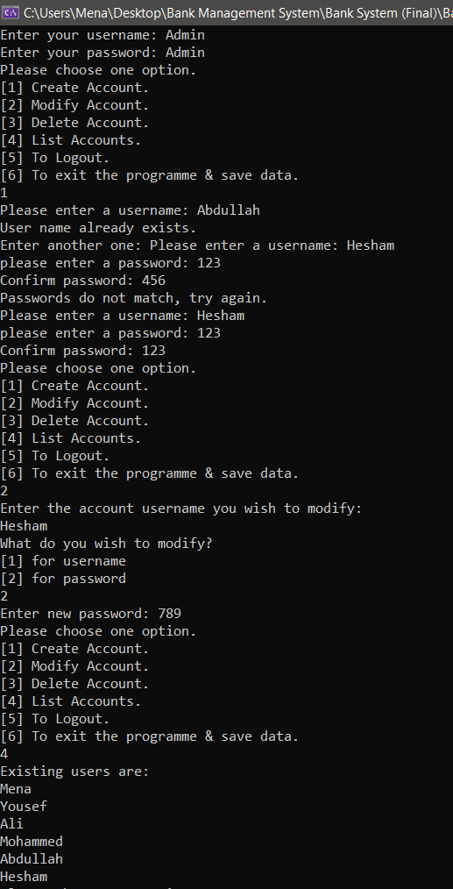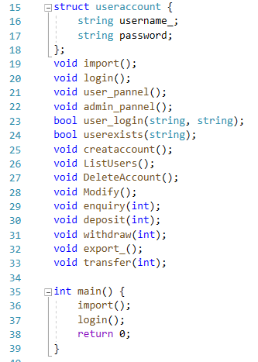

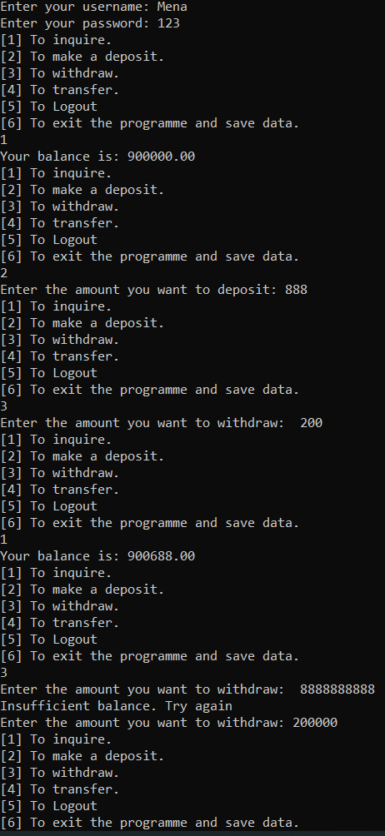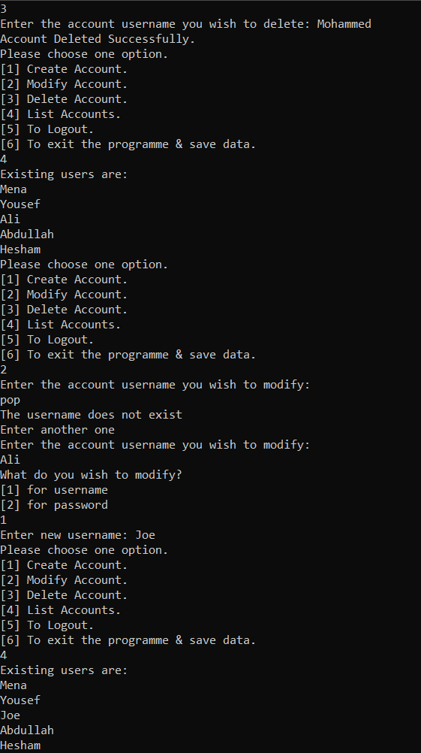More Admin Panel Commands: User Panel Commands:

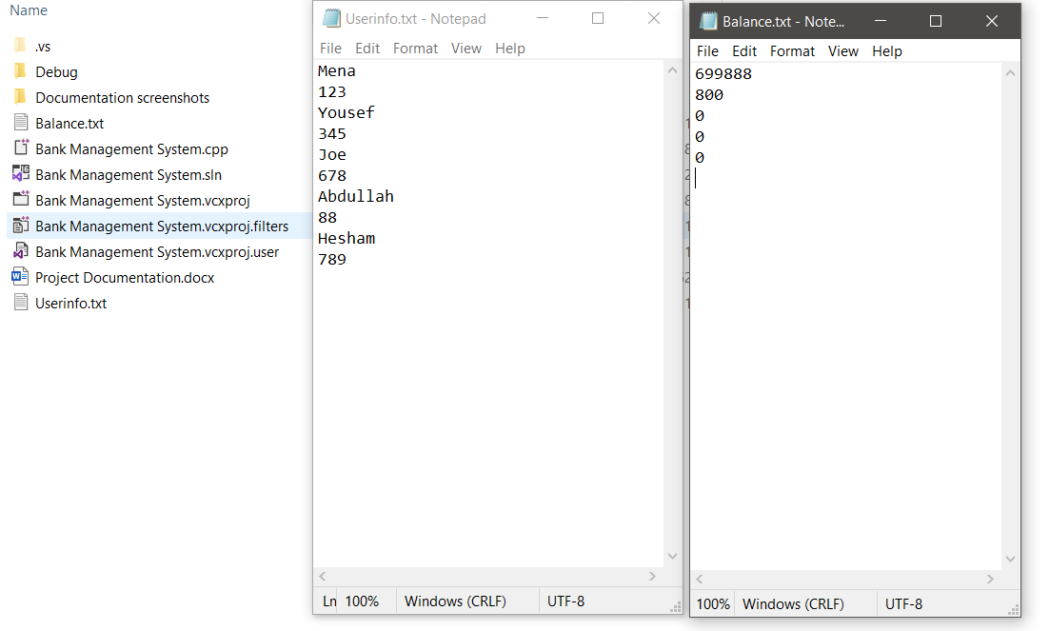Data Saved to File: